SAP 2 – Procurement, Goods Receipt and Payment
MGIS 4580 – Fall 2023 DELIVERABLE

Create Purchase Orders

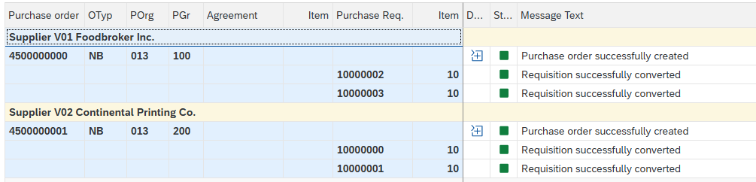

View Purchase Orders
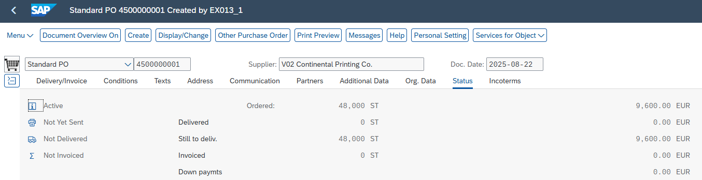
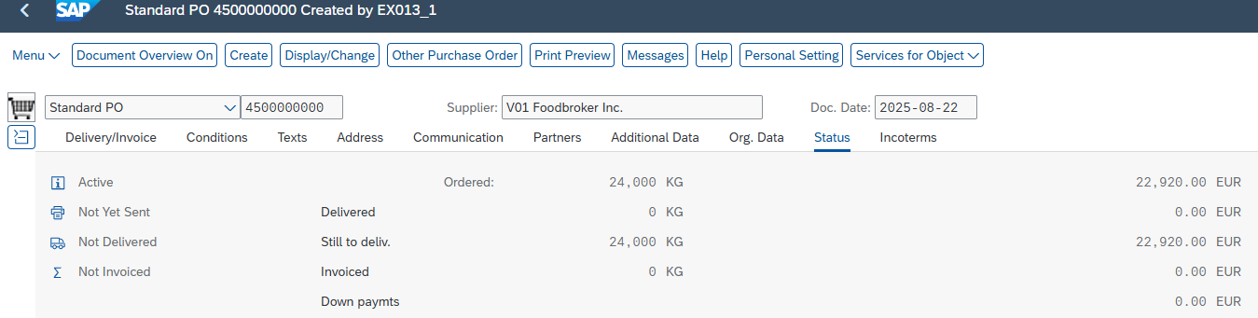

Receive Raw Materials

View Goods Receipt Documents
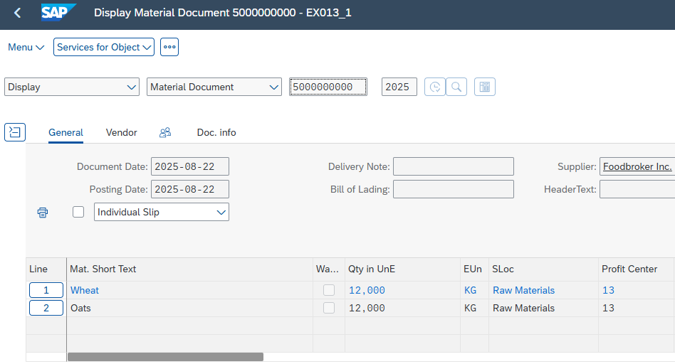
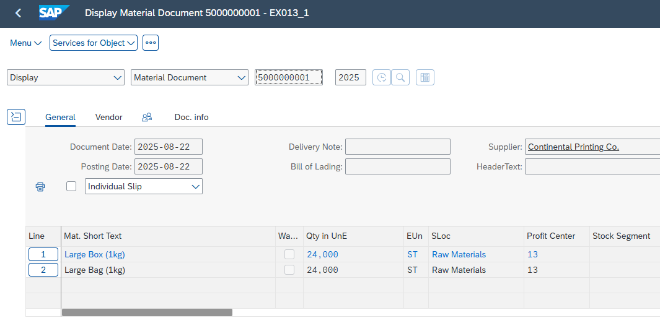

Record Vendor Invoice
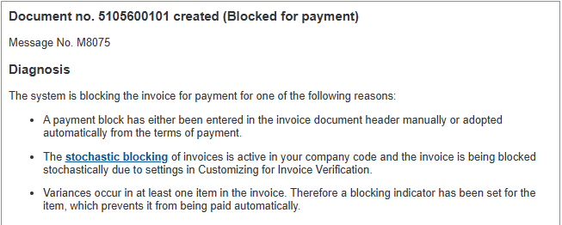
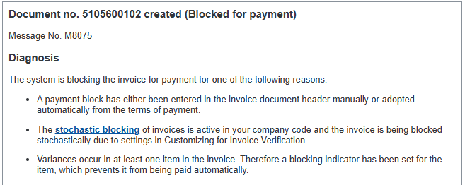

Post Outgoing Payment
